Assignment 6:1

Assignment 6.1

Task Description #1 (Classes – Employee Management)
• Task: Use AI to create an Employee class with attributes (name,
id, salary) and a method to calculate yearly salary.
• Instructions:
o Prompt AI to generate the Employee class.
o Analyze the generated code for correctness and structure.
o Ask AI to add a method to give a bonus and recalculate
salary.
Expected Output #1:

• A class with constructor, display_details(), and calculate_bonus()
methods.
Prompt: Task Description #1 (Classes – Employee Management) • Task: Use AI to create an Employee class with attributes (name, id, salary) and a method to calculate yearly salary. • Instructions: o Prompt AI to generate the Employee class. o Analyze the generated code for correctness and structure. o Ask AI to add a method to give a bonus and recalculate salary. Expected Output #1: • A class with constructor, display_details(), and calculate_bonus() methods. give full code and also print the Output
Code and Output:

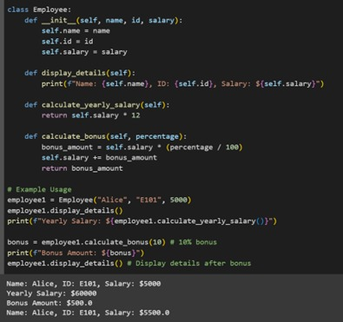

Observation:In this question we can understand that the ai is not printing the output and also it just giving the def part So we add to ask the AI to print the Output by taking the input in the code .

Task Description #2 (Loops – Automorphic Numbers in a Range)
• Task: Prompt AI to generate a function that displays all
Automorphic numbers between 1 and 1000 using a for loop.
• Instructions:
o Get AI-generated code to list Automorphic numbers using
a for loop.
o Analyze the correctness and efficiency of the generated
logic.
o Ask AI to regenerate using a while loop and compare both
implementations.
Expected Output #2:
• Correct implementation that lists Automorphic numbers using
both loop types, with explanation.

Propmpt: Task Description #2 (Loops – Automorphic Numbers in a Range) • Task: Prompt AI to generate a function that displays all Automorphic numbers between 1 and 1000 using a for loop. • Instructions: o Get AI-generated code to list Automorphic numbers using a for loop. o Analyze the correctness and efficiency of the generated logic. o Ask AI to regenerate using a while loop and compare both implementations. Expected Output #2: • Correct implementation that lists Automorphic numbers using both loop types, with explanation. print the output with this code
Code and Output:
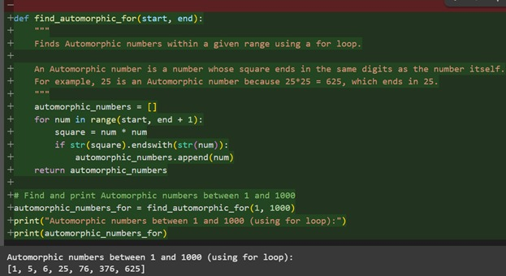

Observation : In this code we can Observe that the AI is not giving the Print by default we have to say AI to print an Output .

Task Description #3 (Conditional Statements – Online Shopping
Feedback Classification)
• Task: Ask AI to write nested if-elif-else conditions to classify
online shopping feedback as Positive, Neutral, or Negative based
on a numerical rating (1–5).
• Instructions:
o Generate initial code using nested if-elif-else.
o Analyze correctness and readability.
o Ask AI to rewrite using dictionary-based or match-case
structure.
Prompt: Task Description #3 (Conditional Statements – Online Shopping Feedback Classification) • Task: Ask AI to write nested if-elif-else conditions to classify online shopping feedback as Positive, Neutral, or Negative based on a numerical rating (1–5). • Instructions: o Generate initial code using nested if-elif-else. o Analyze correctness and readability. o Ask AI to rewrite using dictionary-based or match-case structure. print the ouput
Code and Output:
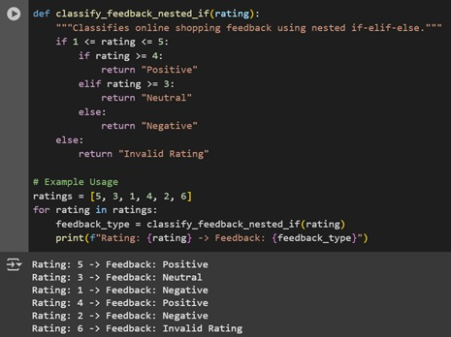

Observation: In this code we observe our prompt that if we mention to print the Output then Only it is printing the output…

Task Description #4 (Loops – Prime Numbers in a Range)
• Task: Generate a function using AI that displays all prime
numbers within a user-specified range (e.g., 1 to 500).
• Instructions:
o Get AI-generated code to list all primes using a for loop.
o Analyze the correctness and efficiency of the prime-
checking logic.
o Ask AI to regenerate an optimized version (e.g., using the
square root method).
Expected Output #4:
• Python program that lists all prime numbers within a given range,
with an optimized version and explanation.
Prompt: Task Description #4 (Loops – Prime Numbers in a Range)
• Task: Generate a function using AI that displays all prime
numbers within a user-specified range (e.g., 1 to 500).
• Instructions:
o Get AI-generated code to list all primes using a for loop.
o Analyze the correctness and efficiency of the prime-
checking logic.
o Ask AI to regenerate an optimized version (e.g., using the
square root method).
Expected Output #4:
• Python program that lists all prime numbers within a given range,
with an optimized version and explanation.Also print the Output for the code
Code and Output:

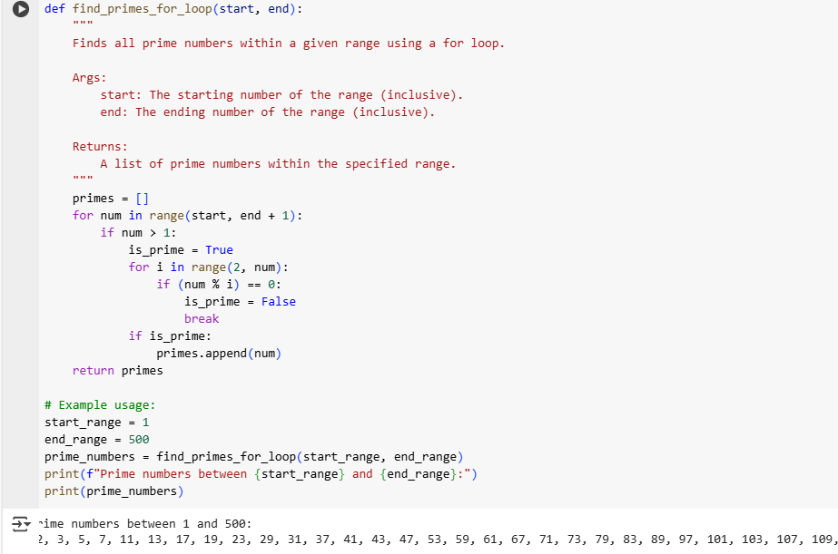

Observation: In this code we can Observe that the code is Giving the output but we didn’t mention to print the output because if we see the task it clearly says to print the prime numbers between 1 to 500.

Task Description #5 (Classes – Library System)

• Task: Use AI to build a Library class with methods to
add_book(), issue_book(), and display_books().
• Instructions:
o Generate Library class code using AI.
o Analyze if methods handle edge cases (e.g., issuing
unavailable books).
o Ask AI to add comments and documentation.
Expected Output #5:
• Library class with all methods, inline comments, and explanation.

PROMPT: (Classes – Library System)• Task: Use AI to build a Library class with methods to add_book(), issue_book(), and display_books().• Instructions:o Generate Library class code using AI.o Analyze if methods handle edge cases (e.g., issuing
unavailable books).o Ask AI to add comments and documentation.Expected Output :
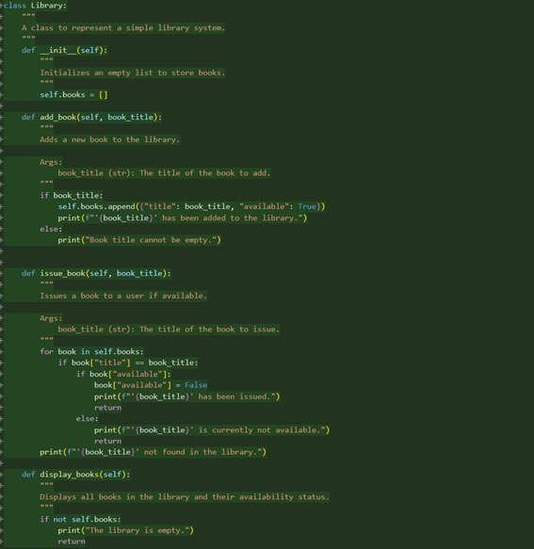
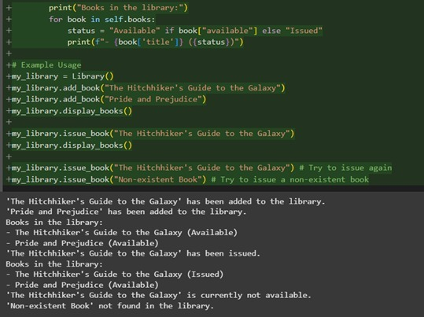
• Library class with all methods, inline comments, and explanation.
CODE AND OUTPUT:

